SQL Injection in /Admin/login.php Row 10 and 11 has vulnerability

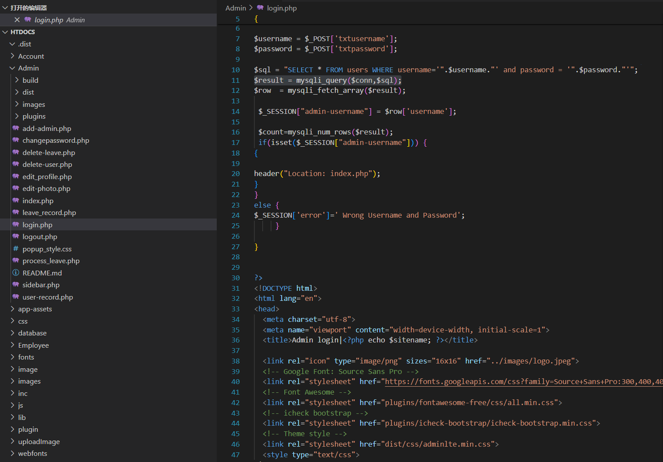

$result = mysqli_query($conn,$sql);

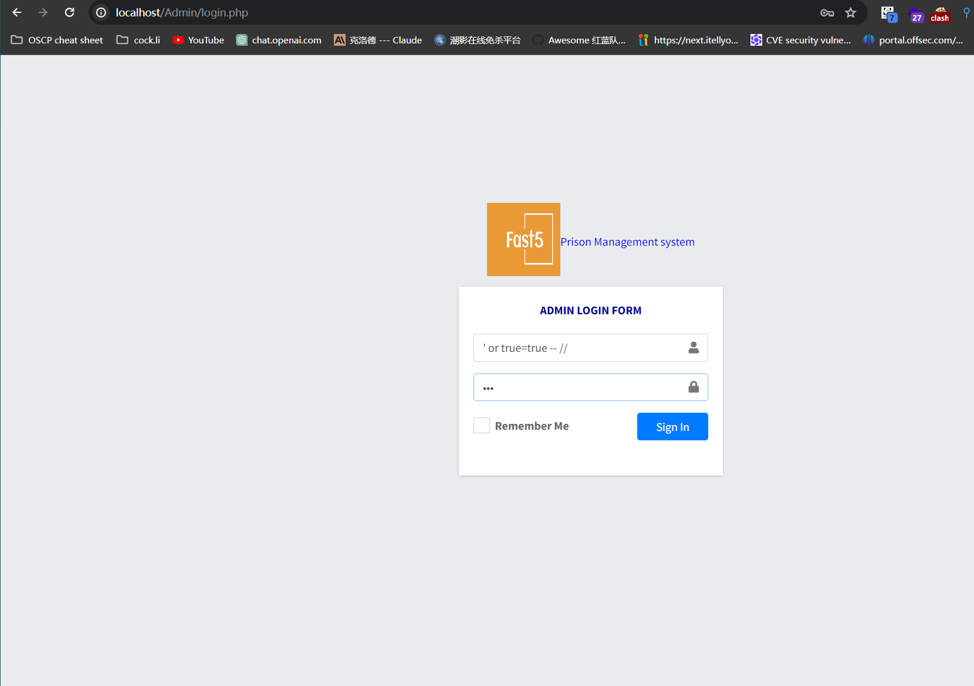

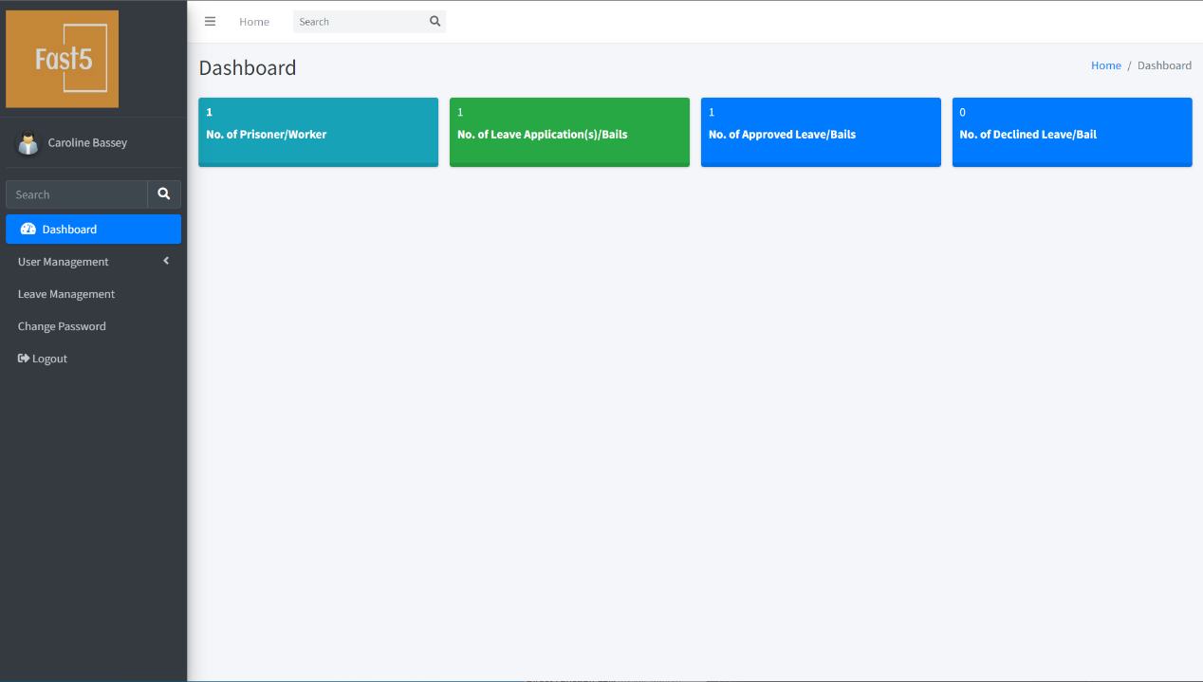

SELECT * FROM users WHERE username= or true=true -- //**''' and password = '".$password."'";** which is Spliced sql statements

